Year 12 Semester 1 Exam 2014

Section One: Multi choice 25% (50 Marks)

1. C | 2. B | 3. C | 4. B | 5. D
6. C | 7. B | 8. A | 9. C | 10. B
11. C | 12. C | 13. C | 14. B | 15. B
16. C | 17. D | 18. C | 19. C | 20. B
21. A | 22. B | 23. A | 24. B | 25. D

Section Two: Short answer 35% (70 Marks)

Question 26 (2 marks)

Write the equilibrium constant expression for each of the following.

Equation | 4 HCl_{(g)} + O_{2 (g)} 2 H₂O_{(g)} + 2 Cl_{2 (g)}
Equilibrium constant expression | K = [Cl₂]² [H₂O]  [HCl]⁴ [O₂] (1 mark)

Equation | OCl –_{(aq)} + H₂O_{(l)} HOCl_{(aq)} + OH⁻_{(aq)}
Equilibrium constant expression | K = [HOCl] [OH⁻]  [OCl –] [1 mark]

Question 27 (4 marks)

Write the equation for the reaction that occurs in each of the following procedures. If no reaction occurs, write ‘no reaction’. For full marks, chemical equations should refer only to those species consumed in the reaction and the new species produced. These species may be ions [for example Ag⁺(aq)], molecules [for example NH₃(g), NH₃(aq), CH₃COOH()] or solids [for example BaSO₄(s), Cu(s), Na₂CO₃(s)].

(a) copper carbonate solid is mixed with hydrochloric acid solution. [2 marks]
Equation: 2 H⁺_{(aq)} + CuCO_{3 (s)} Cu⁺²_{(aq)} + H₂O_{(l)} + CO_{2(g)}

(b) barium metal is mixed with sulfuric acid solution. [2 marks]
Equation: Ba_{(s)} + 2H⁺ + SO₄²⁻ _{(aq)} BaSO_{4 (s)} + H_{2(g)}

Question 28 (7 marks)

a) Use 2 examples to explain how VSEPR(Valence shell electron pair repulsion) theory helps explain a molecule’s shape?
VSEPR states that e repel each other(1) and will move as far away from each other as possible. Therefore you must look at the No of e around the central atom(1). In BN₃ there are three pairs and they spread out and assume a triangular planar shape(1). For methane there are 4 pairs and they spread out and form a 3-D tetrahedral shape to give the e pairs sufficient space(1).
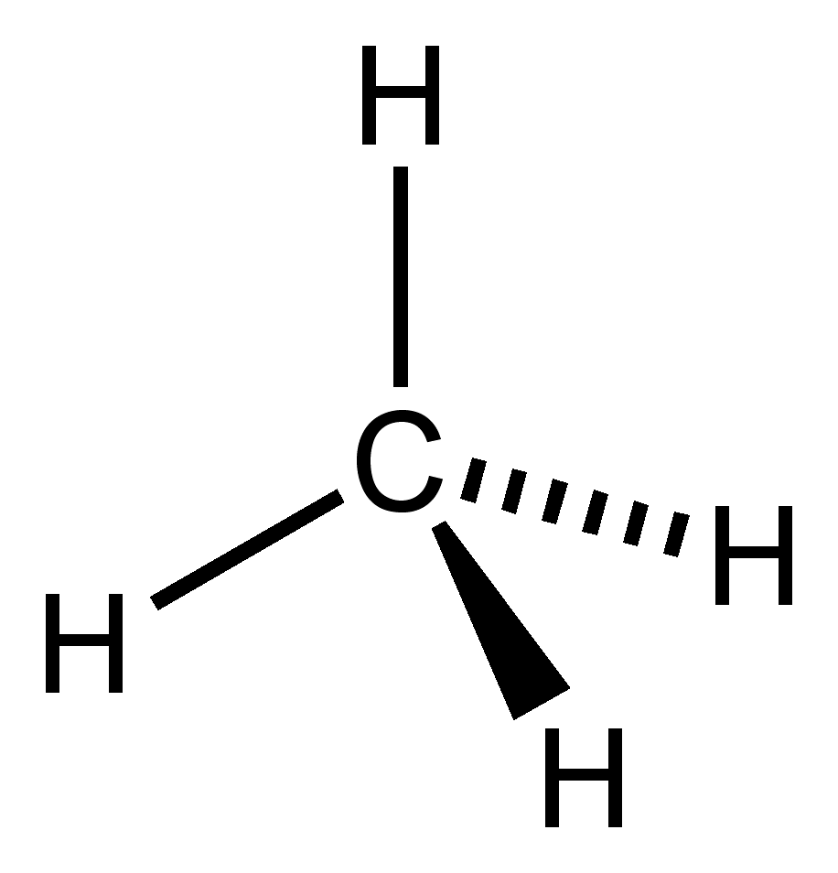
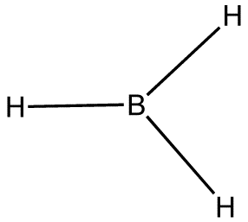 [4 marks]
b) How is polarity related to bond strength? [3 marks]
In IM forces the greater the polarity the stronger the IM force (1). For example the strongest IM force is H-bonding and it involves very polar molecules (1) whereas the weakest IM force Dispersion involves non-polar molecules(1). This of course is when the molecules are similar in size.
If you assumed the question is about covalent bonds then -Polarity does not really affect bond strength(1). All Cov mol substance have shared e’s(1) and most have polar bonds. Polarity depends on whether the combination of shape and polar bonds produces a net dipole(1), therefore it is not really related to bond strength.
Question 29 (4 marks)

Chlorine bleach contains the active ingredient sodium hypochlorite (NaOCl) at a concentration of 5.25%. If the required concentration to kill bacteria is 25-200ppm of sodium hypochlorite,

- What minimum amount of bleach would you need to add to a bucket of water holding 3.00 L of water? (assume density of bleach solution is 1.00gmL⁻¹)
[3 marks]
25 ppm minimum therefore 25 mg in 1.00 kg (1)
Since 3.00 L is 3.00 kg we need 75 mg of sodium hypochlorite (NaOCl) (1)
Therefore need 75 x 10⁻³ x 100 /5.25 = 1.428 g or 1.428 mL as density is 1.00 (1)

- Discuss any other factors that might affect how long the bleach takes to kill the bacteria. [1 marks]
Discuss any two of :Temperature, type of bacteria, amount of bacteria
Question 30 (5 marks)

In order to help prevent tooth decay, fluoride ions at a level of 0.9 mg L^{–1} of F– are added to Melbourne’s public water supplies. The fluoride ions are obtained by adding sodium fluoride (NaF) to the water.

- Calculate the mass of sodium fluoride in mg that must be present in one litre of water to produce a concentration of fluoride ions of 0.90 mg L^{–1}.

m(F) = 0.9 x 10⁻³ g m(NaF) = z
19/41.99 x z = 0.9 x 10⁻³ z = 1.99x 10-³ g [2 marks]
- What mass of sodium fluoride, in kilogram, must be added to a 750 ML reservoir (1 ML = 10⁶ L) to produce a concentration of fluoride ions of 0.90 mg L^{–1}?
1.99 x 10⁻³ x 750 x 10⁶ = 1.49 x 10⁶ g [1 mark]
- Calculate the number of fluoride ions swallowed by a person who drank one litre of water from the reservoir.
0.9 x 10⁻³ g -1L n(F) = 0.9 x 10⁻³ /19 = 4.74x 10⁻⁵ mol
N(F⁻) = 4.74 x 10⁻⁵ x 6.023 x 10²³ = 2.853 x 10¹⁹ [2 marks]
Question 31 (4 marks)

(a) manganese dioxide is added to hydrogen peroxide solution. [2 marks]
Observation: The solution fizzes vigorously(1) producing a c/less gas. Black granules float in a clear solution.(1)

(b) copper nitrate solution is mixed with sodium hydroxide solution. [2 marks]
Observation:Blue solid(1) forms in a c/less solution(1)

Question 32 (8 marks)

Molecule | Major type of intermolecular attraction | Boiling point ranking
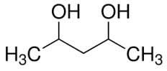 | H-bonding | 1
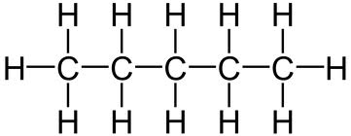 | Dispersion | 4
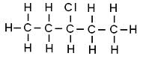 | Dipole | 3
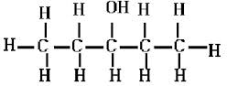 | H-bonding | 2

Question 33 (6 marks)

The graph shows the variation in concentration of reactant and products as a function of time for the following system.
COCl₂(g) → Cl₂(g) + CO(g) ΔH =+108 kJ
Identify and explain each of the changes in conditions that have shaped the curves during the time the system was observed.
Time 4: temp increases, system wants to decrease temp(1) & favours side which is endo-forward therefore CO and Cl₂ increase ans COCl₂ deacreases(1).
Time 10: [CO] decreases, system wants to increase[CO](1). Favours forward so CO and Cl₂ increase and COCl₂ decrease(1).
Time 14: Volume increase as conc of everything drops(1), system wants to increase conc of everything & favours side with more molecules therefore forward so CO and Cl₂ increase and COCl₂ decrease(1).
Question 34 (6 marks)

Molecule | Structural formula  (showing all valence shell electrons) | Shape  (sketch or name) | Polarity
Hydrogen-phosphate ion | 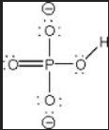 | tetrahedral | polar
ethane | 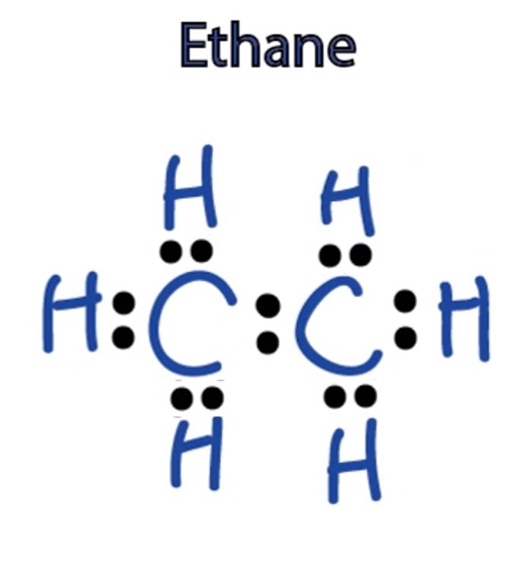 | tetrahedral | Non-polar

Question 35 (6 marks)

At a particular temperature, iodine trichloride dissociates into iodine gas and chlorine gas according to the following equation:
2ICl_{3(g)} → I_{2(g)} + 3Cl_{2(g)} ΔH = 240 kJ
Initially 0.35 mol of ICl_{3(g)} was introduced into a 1.0 L container and allowed to come to equilibrium. At equilibrium there was 0.45 mol L^{–1} of Cl_{2(g).}

a) Write the equilibrium constant expression for this reaction.
K = [Cl₂]³[I₂]
[ICl₃]² [1 mark]
b) Calculate the value of K at this temperature.

K = [0.45]³ x 0.15/[0.05]² = 5.467 [3 marks]
c) What are two consequences of increasing the temperature of the mixture at equilibrium?
Temp increased, system wants to decrease temp therefore favours endo which is forward. (1) since [products] is increased K will increase(1) [2 marks]
Question 36 (6 marks)

In class you have looked at the equilibrium between two cobalt complex ions, shown in the equation below. This equilibrium is set up when cobalt chloride is dissolved in dilute hydrochloric acid
Co(H₂O)₆²⁺ + 4Cl⁻ ↔ CoCl₄²⁻ + 6H₂O
red deep blue
What is done | How the equilibrium shifts.  Write ‘→’, ‘←’ or ‘no change’ | What is observed.  Give the complete observation.
A little concentrated hydrochloric acid is added to the first tube. | → | Solution is more blue in colour
A little silver nitrate  solution is added to  the second tube. | ← | White precipitate forms and Solution is more red in colour
A little concentrated cobalt nitrate solution is added to the third tube. | no change’ | no change’
Question 37 (7 marks)
- The graph below shows the first ionisation energies for the group 1 elements.

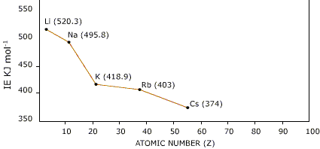
Explain the trend shown in the graph.
As you go down the group the first ionisation energy goes down also as the outer e is further from the nucleus(1) and therefore not held as strongly requiring less energy to be removed(1). [2 marks]
- How would the graph be similar and different if group 17(halogens) had been used
If the first ionisation energy for group 17 had been viewed it would follow the same pattern as group 1 for the same reason (1) however, the values for all would be significantly higher as halogens have more positive charge in the nucleus compared to group 1 element s in the same period and therefore will attract outer e more strongly making ionisation energy much larger(1). [2 marks]
- An element has the first five successive ionisation energies.
 | 1st | 2nd | 3rd | 4th | 5th
Successive ionisation energy(kJ/mol) | 600 | 1200 | 4900 | 6500 | 8200
Which group does the element belong to and explain your reasons for this choice.
2 e (1)as the biggest jump as after the 2nd is removed(1). The large jump after two suggests the third e has come from an energy level closer to the nucleus(1) and a full shell requiring a lot more energy to remove it(1). [3 marks]
Question 38 (5 marks)
The nitrogen content of bread was determined using the following procedure:
- A sample of bread weighing 2.80 g was analysed.
- The nitrogen in the sample was converted into ammonia.
- The ammonia was collected and completely neutralised in 30.0 mL of 0.125 mol L⁻¹ hydrochloric acid.
(a) Write a balanced ionic equation for the reaction involving hydrochloric acid.
NH₃ + H⁺ → NH₄⁺ [1 mark]

(b) Calculate the moles of hydrochloric acid.
n(HCl) = 0.03 x 0.125 = 0.00375 mol [1 mark]
(c) Calculate the moles of ammonia.
n(NH₃) = 0.00375 mol [1 mark]
(d) Calculate the percentage by mass of nitrogen in the bread.
n(N) = n(NH₃) = 0.00375 mol
m(N) = 0.300375 x 14.01 = 0.0525 g
% N = 0.0525/280 x 100 = 1.876% [2 marks]

End of Section Two
Section Three: Extended answer 40% (75 Marks)

Question 39 (13 marks)

Fungi and mildews can cause great damage to grape vines. One spray used to combat these diseases is called Bordeaux mixture. A home gardener who wishes to treat his grapes with Bordeaux mixture prepares a mixture using the instructions given below.
1. Add 25.0 g of calcium hydroxide powder to 25.0 g of copper(II) sulfate pentahydrate powder.
2. Mix these powders with a small amount of water to make a paste.
3. Add the paste to 5.00 L of water and mix well.
4. Use the mixture immediately after preparation.
(a) Write a balanced molecular or ionic equation for any reaction that occurs after the powders are mixed with water. (2 marks)

Cu²⁺(aq) + 2 OH–(aq) → Cu(OH)₂(s)

or

CuSO₄(aq) + Ca(OH)₂(aq) → Cu(OH)₂(s) + CaSO₄(s)

(b) Determine the limiting reagent for the above reaction. (4 marks)

Ca(OH)₂ : CuSO₄ • 5H₂O = 1:1 ∴ CuSO₄ is limiting reagent

(c) Calculate the mass of reagent in excess. (2 marks)

Reagent in excess = Ca(OH)₂

n[(Ca(OH)₂] remaining = (3.374 × 10^{–1}) – (1.0012 × 10^{–1}) = 0.23728 mol

∴ mass (Ca(OH)₂ remaining) = 0.23728 × 74.096 = 17.58 g = 1.76 × 10¹ g

(d) What colour (if any) will the solution have? (1 mark)

Colourless

(e) The concentration of Bordeaux mixture is traditionally given by the percentage of the weight of copper(II) sulphate to the weight of water in the mixture. If the density of the water is 1.00 g mL -1, calculate the concentration of the mixture. (2 marks)

% Cu is 25/5000 x 100 = 0.5

(f) The most effective Bordeaux mixture actually has more copper(II)sulphate than calcium hydroxide. In fact there can be half the mass of calcium hydroxide present and it will still be effective. These mixtures rarely use less calcium hydroxide as it tends to deteriorate by reacting with carbon dioxide in the air. Show the equation for the calcium hydroxide deteriorating. (2 marks)

Ca(OH)₂(aq) + CO₂ (g) → CaCO₃(s) + H₂O_{(l)}

Question 40 (12 marks)

The main source of the element magnesium in Australia is the ore magnesite, in which magnesium is present as magnesium carbonate (MgCO₃).
a) Calculate the percentage by mass of magnesium in magnesium carbonate.
% Mg = 24.31/84.32 x 100 = 28.8% [1 mark]
b) Magnesium carbonate reacts with dilute hydrochloric acid; Write a balanced equation for this reaction.
MgCO_{3(s)} + 2H⁺_{(aq)} → Mg²⁺_{(aq)} + CO_{2(g)} + H₂O_{(l)} [1 mark]
A series of laboratory experiments was set up to study the rate of this reaction under some different conditions. The initial reaction rate was determined by measuring the rate of evolution of CO₂ in a gas syringe as shown in the following diagram.

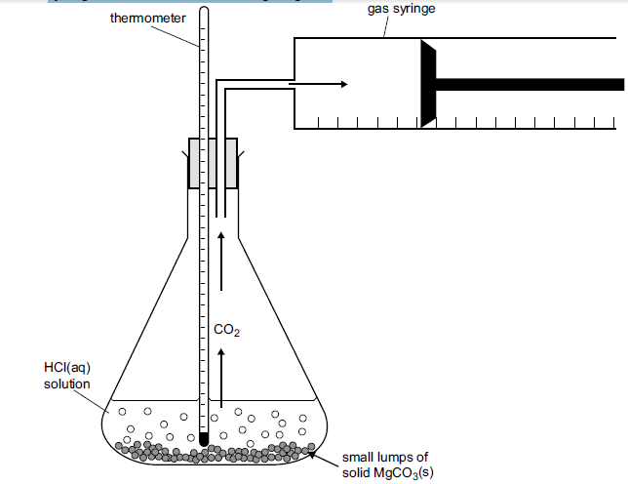
Four experiments were carried out as follows. In each case, the amount of HCl present was in excess.
Experiment | [HCl] (mol L⁻¹⁾ | Mass of MgCO_{3(s)} | Initial temp in °C | Final temp in °C | Initial rate of CO₂ evolution in  mL min^{–1}
1 | 0.10 | 1.0 | 20 | 25 | 5
2 | 0.10 | 1.0 | 30 | 35 | 50
3 | 0.10 | 2.0 | 20 | 30 | 10
4 | 0.20 | 1.0 | 20 | 25 | 20
c) Results from experiment 4 are plotted on the sketch graph below. On the same axes, sketch the results from the other experiments.
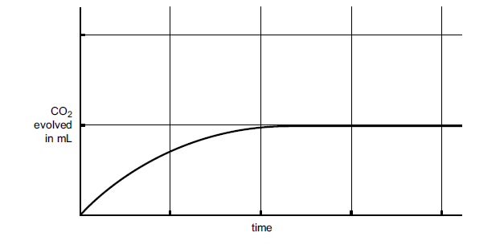[3 marks]
Experiment 1 will be same shape but less steep and reach same height as 4
Experiment 2 will be same shape but much steeper and reach the same height as 4
Experiment 3 will be same shape but twice the height of 4
d) Comment on the factor which increases rate most significantly.
Temperature- plus some explanation [1 mark]
e) You are now going to use the trial performed to plan an investigation into the factor you think was most significant. Outline what you would do in your investigation.
Need to describe their method-must follow scientific method-have one Independent and one dependent variable. (1) Should list things they are keeping constant (1) Should have good range of trials (1 choices of trial(1)). Should do repeats. (1) Should indicate what they are measuring (1)
[6 marks]
Question 41 (15 marks)

A chlorofluorocarbon (a compound containing only chlorine, fluorine and carbon) is analysed by preparing two identical samples of the compound of mass 2.320 g. The first sample is burnt in excess oxygen gas to convert all the carbon it contains into carbon dioxide. The second sample of the compound is chemically treated to convert all the chlorine it contains into hydrochloric acid.
a) Given that the mass of carbon dioxide produced is 0.9267 g and the hydrochloric acid produced requires 17.2 mL of a 3.062 mol L⁻¹ ammonia solution for complete neutralisation, calculate the empirical formula of the chlorofluorocarbon.
CFCL + O₂ →CO₂ + H₂O→→HCl + NH₃ → NH₄Cl
2.320 g 0.9267 g V = 0.172 L
m(C) = 12.01/44.01 x 0.9267 c = 3.062 mol L-1
= 0.2523 g (1) n = 0.052666 = n(Cl-)
m(Cl-) = 1.867 g (1)
m(F) = 2.320-m(C)- m(Cl)= 0.200 (1)
 | C | Cl | F
Mass | 0.2523 | 1.867 | 0.2
n | 0.021056 | 0.052666 | 0.01053 (1)
ratio | 2 | 5 | 1 (1)
 | C₂Cl₅F

b) When a 1.503 g sample of the compound is vaporised in the absence of air, the vapour occupies 152.8 mL at S.T.P. From this data, calculate the molecular formula of the compound.
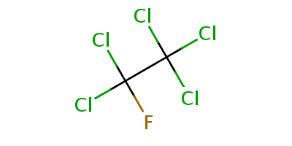
n = 0.1528/22.71 = 0.006728 mol
M = m/n = 1.503/0.006728 = 223.4 g

m(MF) = 223.4 = 1 molecular formula is C₂Cl₅F
m(EF) 220

[3 marks]
c) Draw a possible structure of the chlorofluorocarbon. [2 marks]

d) The reactions of fluorine and chlorine with methane are quite vigorous. Fluorine is the most reactive. If no precautions are taken, a mixture of fluorine and methane explodes whilst the reaction between methane and chlorine is easily controllable.
In a reaction of methane with chlorine the activation energy is 242 kJ and the heat of reaction is -105 kJ.
Draw labelled energy profile diagram for this reaction to scale. On the same diagram predict what the energy profile diagram for the reaction of methane and fluorine would look like.
1-shape
1-exo
1-labels and scale
1-shape for fluorine
1-fluorine should be smaller Ea and larger ΔH
[5 marks]
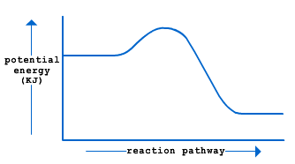

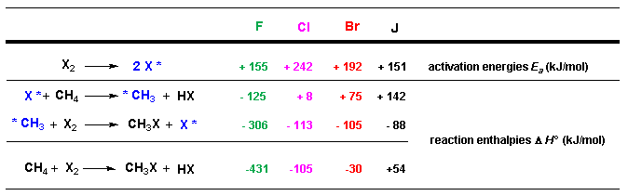

Question 42 (10 marks)

Arsenic is analysed in the following way.
Samples are heated strongly with excess sodium peroxide so the mixture melts and the
arsenic is converted to sodium arsenate:
2As + 5Na₂O₂ → 2Na₃AsO₄ + 2Na₂O
The product is cooled and dissolved in water.
Na₃AsO₄ → 3Na⁺ + AsO₄ ³⁻
Dilute nitric acid is added and the solution is boiled and the arsenate ion is converted to ‘dihydrogenarsenate’ ion.
AsO₄ ³⁻ + 2H⁺ → H₂AsO₄ ⁻
Silver nitrate is added to precipitate silver arsenate:

H₂AsO₄ ⁻ + 3Ag⁺ → Ag₃AsO₄ + 2H⁺
The silver arsenate is filtered and washed. It is then dissolved in dilute nitric acid to produce silver ion:
Ag₃AsO₄ + 3H⁺ → H₃AsO₄ + 3Ag⁺
The silver ion is then reacted with potassium thiocyanate solution, as follows:
Ag⁺ + NCS⁻ → AgNCS
A 0.0320g sample of commercial arsenic metal is treated as described, and ultimately when processed it requires 24.36mL of 0.0506 mol L⁻¹ potassium thiocyanate solution in the last step.

- Use the above equations to work out how many moles of thiocyanate ion will react
with the silver ion produced from 1 mole of commercial arsenic.
2 As → 6 AgNCS therefore 1 mole As produces 3 mole AgNCS [3 marks]
- Use this value to calculate the percentage by mass of arsenic in the sample
n(NCS-) = 0.0506 x 0.02436 = 0.0012326 mol.(1)
n(As) = 0.0012326/3 = 0.0004108(2)
m(As) = 0.0004108 x 74.92 = 0.03078(2)
% purity = 0.03078/0.032 x 100 = 96.19 %(2) [7 marks]

Question 43 (13 marks)

Chromium metal occurs mainly as the green mineral chromite, Fe₂O₃.Cr₂O₃. It is extracted from chromite by heating the mineral in air with sodium carbonate to form sodium chromate according to the following balanced equation:
2Fe₂O₃.Cr₂O₃ + 4Na₂CO₃ + 3O₂(g) → 2Fe₂O₃ + 4Na₂CrO₄(s) + 4CO₂(g)

(a) Calculate the mass of sodium carbonate needed to react with 1.00 tonne of chromite.
[Hint: 1 tonne = 10³ kg or 10⁶ g.]
n(Fe₂O₃.Cr₂O₃ ) = 1 x 10⁶/ 311.7 = 3208 mol (2)
n(Na₂CO₃) = 3208 x 2 = 6416 mol (1)
m(Na₂CO₃) = n x M = 6416 x 105.99 = 6.80 x 10⁵ g (2) [5 marks]

(b) What volume of oxygen gas measured at 30.0ºC and 98.0 kPa pressure is required
for the reaction in (a) above?
n(O₂) = 3208 x 3/2 = 4812.3 mol(2)
PV=nRT(1)
V = 4812.3 x 8.314 x 303.1/98 = 1.24 x 10⁵ L(1) [4 marks]

(c) If the reaction is only 78% efficient calculate the amount of sodium chromate produced from the reaction.
n(Na₂CrO₄) = 3208 x 2 = 6416 mol(1)
m(Na₂CrO₄) = 6416 x 161.98 = 1.039 x 10⁶ g (2)
78% efficiency Therefore 8.10 x 10⁵ g (1) [4 marks]
Question 44 (12 marks)

The melting point and boiling points of four substances are listed in the table below. Describe how an understanding of the forces between atoms in these substances can be used to explain the wide range of the values.

Substance | Melting Point (ºC) | Boiling Point (ºC)
F₂ | -219 | -188
HF | -83 | 19.5
NaF | 993 | 1700
SiC | Decomposes at 2000 | Not applicable

Your answer should be approximately one to two pages in length.

Substance | Bonding | Properties
F₂ | Covalent molecular 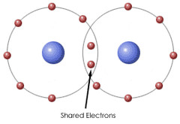  shared e(1) | Solids are easily melted (and generally soft) and most are liquids and gases due to very weak bonds between different molecules.  No charge carriers hence non conducting. Fluorine is non polar therefore has the weakest IM force dispersion which explains the very low MP. In particular dispersion force related to no of e and fluorine only has 18 therefore weak dispersion(2)
HF | Covalent molecular    shared e(1) | Solids are easily melted (and generally soft) and most are liquids and gases due to very weak bonds between different molecules.  No charge carriers hence non conducting. Hydrogen fluoride is polar hence has stronger IM forces than fluorine. Has H-bonding the strongest IM force hence explains the higher MP(2)
NaF | Ionic  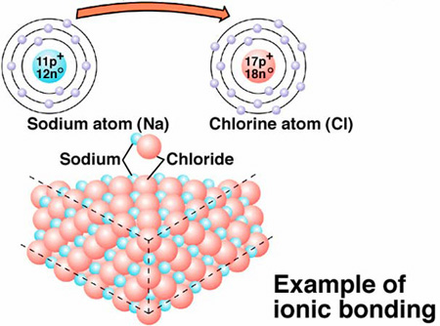composed of ions in large lattice(1) | A strong impact may disrupt the lattice causing like charged ions to align and hence repel. Bonds are strong but rigid. Only when melted or dissolved are ions free to move and hence electricity can conduct. Because there are strong forces of attraction between ions the MP is very high(2)
SiC | Covalent network  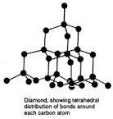shared electrons but in large lattice(1) | Lattice of atoms strongly attracted by covalent bonding: “giant molecule”. 3-D structure.  Electrostatic attraction is strong throughout the crystal. To remove one atom need to break 4 covalent bonds. Therefore very high MP(2)

